**Week-7**

**ReactJS-HOL**

**9. ReactJS-HOL hands-on**

**Create a React Application named “cricketapp” with the following components:**

1. **ListofPlayers**

* **Declare an array with 11 players and store details of their names and scores using the map feature of ES6**
* **Filter the players with scores below 70 using arrow functions of ES6.**

1. **IndianPlayers**
   1. **Display the Odd Team Player and Even Team players using the Destructuring features of ES6**
   2. **Declare two arrays T20players and RanjiTrophy players and merge the two arrays and display them using the Merge feature of ES6**

**Code:**

**ListOfPlayers.js**

import React from 'react';

function ListOfPlayers({ players }) {

  return (

    <div>

      {players.map((item, index) => (

        <li key={index}>Mr. {item.name} <span>{item.score}</span></li>

      ))}

    </div>

  );

}

export default ListOfPlayers;

**ScoreBelow70.js**

import React from 'react';

function Scorebelow70({ players }) {

  const players70 = [];

  players.map((item) => {

    if (item.score <= 70) {

      players70.push(item);

    }

  });

  return (

    <div>

      {players70.map((item, index) => (

        <li key={index}>Mr. {item.name} <span>{item.score}</span></li>

      ))}

    </div>

  );

}

export default Scorebelow70;

**EvenPlayers.js**

import React from 'react';

function EvenPlayers({ IndianTeam = [] }) {

  const [, second, , fourth, , sixth] = IndianTeam;

  return (

    <div>

      <ul>

        <li>Second : {second}</li>

        <li>Fourth : {fourth}</li>

        <li>Sixth : {sixth}</li>

      </ul>

    </div>

  );

}

export default EvenPlayers;

**OddPlayers.js**

import React from 'react';

function OddPlayers({ IndianTeam = [] }) {

  const [first, , third, , fifth] = IndianTeam;

  return (

    <div>

      <ul>

        <li>First : {first}</li>

        <li>Third : {third}</li>

        <li>Fifth : {fifth}</li>

      </ul>

    </div>

  );

}

export default OddPlayers;

**MergePlayers.js**

import React from 'react';

function MergePlayers({ IndianPlayers }) {

  return (

    <div>

      {IndianPlayers.map((player, index) => (

        <li key={index}>Mr. {player}</li>

      ))}

    </div>

  );

}

export default MergePlayers;

**App.js**

import React from 'react';

import './App.css';

import ListofPlayers from './components/ListOfPlayers';

import Scorebelow70 from './components/ScoreBelow70';

import OddPlayers from './components/OddPlayers';

import EvenPlayers from './components/EvenPlayers';

import ListofIndianPlayers from './components/MergePlayers';

const players = [

    { name: "Rohit", score: 88 },

    { name: "Kohli", score: 96 },

    { name: "Gill", score: 85 },

    { name: "MS Dhoni", score: 78 },

    { name: "Hardik", score: 72 },

    { name: "Jadeja", score: 68 },

    { name: "Shami", score: 25 },

    { name: "Bumrah", score: 34 },

    { name: "Surya", score: 81 },

    { name: "KL Rahul", score: 75 },

    { name: "Ashwin", score: 50 }

];

const T20Players = ['First Player', 'Second Player', 'Third Player'];

const RanjiTrophyPlayers = ['Fourth Player', 'Fifth Player', 'Sixth Player'];

const IndianPlayers = [...T20Players, ...RanjiTrophyPlayers];

const flag = true;

function App() {

  if (flag) {

    return (

      <div className='Main'>

        <h1>List of Players</h1>

        <ListofPlayers players={players} />

        <hr />

        <h1>List of Players having Scores Less than 70</h1>

        <Scorebelow70 players={players} />

      </div>

    );

  } else {

    const namesOnly = players.map(player => "Mr. " + player.name);

  return (

    <div className='Main'>

      <div>

        <h1>Indian Team</h1>

        <h1>Odd Players</h1>

        <OddPlayers IndianTeam={namesOnly} />

        <hr />

        <h1>Even Players</h1>

        <EvenPlayers IndianTeam={namesOnly} />

      </div>

      <hr />

      <div>

        <h1>List of Indian Players Merged:</h1>

        <ListofIndianPlayers IndianPlayers={IndianPlayers} />

      </div>

    </div>

  );

  }

}

export default App;

**Output:**

When flag = true

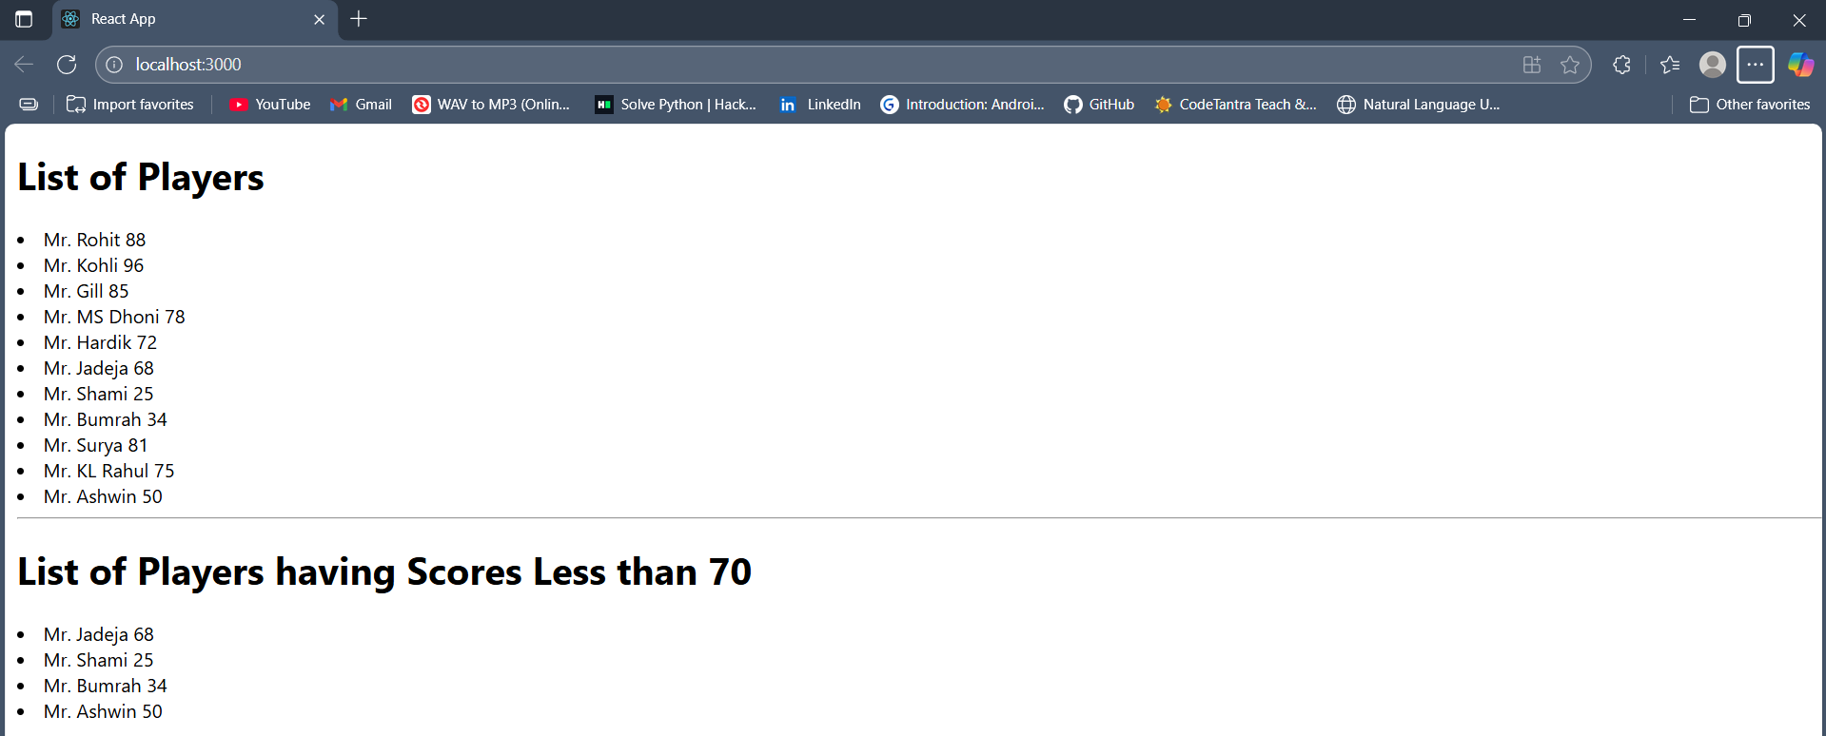

When flag = false

